
Software Engineering Department
Braude College of Engineering
Final Project – Phase A (61998)
UniSched – University Course Timetabling System
Code: 26 – 1- D -13

By:
Gal Moyal
Eden Furman

Advisor:
Dr. Julia Sheidin
Dr. Avital Shulner Tal

Link to GitHub:
https://github.com/GalMoyal111/course-scheduling-system.git
Table of contents
Abstract 3
1. Introduction 4
2. Literature review 5
2.1 The University Course Timetabling Problem (UCTTP) 5
2.2 Solution Approaches for UCTTP 5
2.2.1 OR-Based Techniques 6
2.2.2 Single-Solution Based Meta-Heuristics 6
2.2.3 Population-Based Meta-Heuristics 7
2.2.4 Hyper-Heuristic Approaches 7
2.2.5 Multi-Objective Approaches 7
2.2.6 Hybrid Approaches 7
2.3 Summary 8
3. Development Process 9
3.1 Project Description 9
3.2 Client Interaction During Development 9
3.3 Requirements Elicitation Process 11
3.4 System Requirements 11
3.4.1 Functional Requirements 11
3.4.2 Non-Functional Requirements 11
3.5 Tools and Technologies 12
3.6 System Screens 16
4. Expected Challenges 18
5. Success Metrics 19
6. Evaluation Process 20
6.1 Testing Plan 20
6.2 User Evaluation 21
7. AI Tools and Prompts Used 21
8. References 21
9. Appendices 23

Abstract
This project presents the development of a client-server system designed to automate the academic course timetabling process in the Software Engineering Department at Braude College. The system is intended to replace the existing manual scheduling method with an algorithmic model based on a custom-designed CSP (Constraint Satisfaction Problem) tailored to the department’s rules and constraints. The solution features a Java-based server, a React user interface, and a cloud database, enabling the rapid generation of optimal timetables while fully adhering to hard constraints and improving the department's operational efficiency.

Keywords: scheduling, optimization, algorithm, constraint programming.

1. Introduction
Timetabling is one of the central and most complex tasks in academic institutions such as colleges and universities. It is a combinatorial optimization problem where many courses must be assigned to time slots and rooms while satisfying numerous constraints. Because each institution has its own rules, lecturer availability, room limitations, and internal regulations, there is no single universal solution that fits all cases. For this reason, many departments still rely on manual scheduling, often using Excel files and personal experience.
This is also the current situation in the Department of Software Engineering and Information Systems at Braude College, where the timetable is created manually by Ora, assistant head of Department. During this process she must consider lecturer availability and limitations, classroom capacity and equipment, different course requirements, and the various teaching components of each course, such as lectures, tutorials, and labs. Managing all these constraints by hand makes the process slow, complex, and difficult to adjust when changes occur.
The goal of this project is to develop a complete client–server system that automatically generates a timetable based on a defined set of constraints. The system will include a Java server, a web-based client, and a cloud database. At the core of the solution stands an automatic scheduling algorithm based on the principles of Constraint Satisfaction Problems (CSP). Constraints will be divided into hard constraints, which must always be satisfied, and soft constraints, which represent preferences. The algorithm will aim to produce valid timetables that meet all hard constraints while minimizing violations of soft ones.
By developing this system, we aim to reduce the manual workload, improve the quality and consistency of the timetable, and provide a smarter and more efficient scheduling tool for the department.

2. Literature review
Academic timetabling is a complex and institution-specific problem, characterized by a wide range of constraints that vary between institutions. Differences in academic structures, lecturer availability, classroom resources, and institutional regulations make it difficult to define a single universal solution applicable to all cases [2].
Scheduling systems also exist in other domains, such as employee shift scheduling in organizations and hospitals [5]. While these systems address constraints like availability, labor regulations, and skills, academic timetabling involves additional complexities, including multiple teaching components, study groups, and dependencies between events. As a result, such systems cannot be directly applied to academic course timetabling.
In practice, academic timetabling is supported in some institutions by commercial or in-house scheduling systems. However, the literature reports that such systems often require significant customization to support local academic rules and constraints, and therefore many departments still rely on manual or semi-automated solutions alongside them [2], [3].
Due to this complexity and variability, academic timetabling is commonly addressed through algorithmic approaches. Accordingly, this literature review focuses on the main algorithms and solution methods proposed for the University Course Timetabling Problem (UCTTP) [2].

2.1 The University Course Timetabling Problem (UCTTP)
The University Course Timetabling Problem (UCTTP) is a well-known NP-hard problem in which a set of courses must be assigned to time slots and rooms while satisfying many academic and logistical constraints [2], [1], [7]:
- Hard constraints - conditions that must always be met, such as preventing a lecturer or student from being scheduled for two classes at the same time and ensuring that each room is used for only one event per time slot.
- Soft constraints - represent preferences, such as avoiding a single isolated class during the day or reducing late-hour sessions, and they affect the overall quality of the timetable but do not invalidate a solution.
Because every institution has its own policies, structures, and teaching requirements, UCTTP is highly complex and has become an active research area, leading to many different computational approaches for solving it.

2.2 Solution Approaches for UCTTP
The literature usually classifies the main approaches for solving the University Course Timetabling Problem (UCTTP) into six groups [2]:
- OR-Based Techniques
- Single-Solution Meta-Heuristics
- Population-Based Meta-Heuristics
- Hyper-Heuristic Approaches
- Multi-Objective Approaches
- Hybrid Approaches
Each group has its own characteristics, strengths, and weaknesses, and the choice of method depends on the complexity of the problem, the number of constraints, and the overall size of the timetable.

2.2.1 OR-Based Techniques
One of the early approaches for solving the UCTTP was based on the analogy to the Graph Coloring problem. In this analogy, courses are represented as vertices, conflicts between courses as edges, and time slots as colors. Based on this idea, several heuristics were developed to decide the order in which courses should be scheduled:
- Largest Degree Heuristic – schedule first the courses with the highest number of conflicts.
- Largest Weighted Degree – give priority to courses with many students.
- Saturation Degree – schedule the course whose available time slots are becoming limited first.
- Color Degree Heuristic – give priority to courses that have many conflicts with courses already scheduled.
Another common OR-based approach is to formulate the timetabling problem as a Constraint Satisfaction Problem (CSP). In this formulation, courses or lessons are modeled as variables with domains of possible time-slot and room assignments, subject to hard and soft constraints. The CSP framework enables the use of systematic search methods and heuristics such as Backtracking, Forward Checking, and MRV, and is therefore considered a classical OR-based modeling approach [6], [1].
These methods work well for smaller and simpler cases, but their ability to handle large and complex problems is limited, which led to the development of meta-heuristic approaches.

2.2.2 Single-Solution Based Meta-Heuristics
These methods work with one solution at a time and try to improve it by making small local changes to reduce constraint violations and improve timetable quality. Common methods include:
- Tabu Search (TS) – uses a memory list to avoid repeating moves and helps prevent getting stuck in local minima.
- Simulated Annealing (SA) – begins by allowing worse solutions with some probability to escape local minima, and becomes more selective as the “temperature” decreases.
- Iterated Local Search (ILS) – runs local search until reaching a local minimum, applies a small change, and then runs local search again from the modified solution.
These methods are flexible and efficient but do not guarantee an optimal result and may require careful tuning [2], [8].

2.2.3 Population-Based Meta-Heuristics
These methods work with a population of solutions at the same time, allowing a wider exploration of the search space and reducing the chance of getting stuck in local minima. Common approaches include, [7], [9]:
- Genetic Algorithms (GA) – inspired by evolution. The algorithm selects good solutions, combines them (crossover), and applies small random changes (mutation) to create new solutions. GA can quickly generate improved timetables by mixing strong parts of existing solutions.
- Ant Colony Optimization (ACO) – based on how ants search for food. Solutions are guided by “pheromone” values, which make promising paths more likely to be chosen. ACO can find high-quality solutions but may require significant computation.
- Particle Swarm Optimization (PSO) – simulates a group of moving particles, where each particle shares information about its best position and the best position found by the group. PSO can converge quickly but needs adaptations for discrete problems like timetabling.
Population-based methods explore many possibilities at once but can be more computationally demanding [2].

2.2.4 Hyper-Heuristic Approaches
Hyper-heuristic methods do not solve the timetabling problem directly. Instead, they operate at a higher level by selecting which low-level heuristic to apply at each step. The idea is that the system learns during the search which heuristics are more effective and uses them more often, while avoiding less useful ones. This approach is flexible and can adapt to different types of problems, even when the set of constraints changes between institutions. However, its performance depends on having a good set of low-level heuristics, and it may run slower because each decision requires evaluating several options before choosing the next action [2], [8].

2.2.5 Multi-Objective Approaches
Multi-objective methods try to optimize several goals at once. In UCTTP, these goals often include reducing constraint violations, improving timetable stability, balancing teaching loads, and avoiding unpopular hours. Instead of producing one result, the algorithm creates a Pareto set of solutions, where each solution represents a different balance between the objectives. This gives the institution flexibility to choose the most suitable timetable, although selecting the final option may require extra evaluation [2].

2.2.6 Hybrid Approaches
Hybrid approaches combine several methods to take advantage of the strengths of each one. A common example is creating an initial timetable using Graph Coloring and then improving it with techniques like Tabu Search or Simulated Annealing. Another common combination is using Genetic Algorithms together with local search to refine solutions. These approaches often produce high-quality timetables, especially in complex cases, but they can be harder to implement and may require longer running times. [2], [9], [4].

2.3 Summary
In summary, academic course timetabling is a complex and institution-dependent problem for which no universal solution exists. Although scheduling systems are used in other domains, the unique constraints of academic timetabling require specialized approaches. Consequently, various algorithmic methods have been proposed to address different problem sizes and constraint structures. OR-based techniques are typically suitable for smaller instances, while meta-heuristic, hyper-heuristic, and hybrid approaches are commonly used for larger and more complex scheduling problems.
While meta-heuristic and hybrid approaches offer powerful global optimization, this project adopts a Constraint Satisfaction Problem (CSP) model due to its ability to strictly enforce complex, institution-specific hard constraints. It is important to note that CSP is a modeling paradigm rather than a predefined algorithm. Therefore, the contribution of this project lies in the design of a custom CSP formulation tailored to the department’s academic structure and scheduling rules. This enables the generation of valid and practical timetables beyond what generic allocation methods typically provide.

3. Development Process
The project began with a focused literature review of existing algorithms and solutions for university course timetabling. We then worked closely with Ora, assistant head of Department, the end user of the system, to analyze the current manual scheduling process and identify the need for an automated solution. Based on this process, the system requirements and architecture were defined.

3.1 Project Description
The proposed system is an automated client–server solution for academic timetabling, designed to generate valid and high-quality schedules under a wide set of institutional, lecturer, and course constraints.

3.2 Client Interaction During Development
The interaction with the client - in this case, Ora, assistant head of Department of Software Engineering and Information Systems, was a central part of the development process. Since Ora is responsible for creating the timetable each semester, her knowledge and experience were essential for understanding the system requirements, the existing constraints, and the main challenges of the current manual workflow.
The interaction with Ora began at the early stages of the project, before any code was written or a prototype was developed. During the planning phase, we contacted Ora and observed her manual scheduling process in order to understand how the timetable is constructed in practice, the logic behind the decision-making process, and which constraints affect the schedule in real time. This workflow was documented and is illustrated using an activity diagram that presents the main sequence of actions and decision points involved in building the timetable (see Figure 1).
Following this observation, we worked together with Ora to create a detailed document listing all the constraints that influence the scheduling process. These constraints included lecturer constraints (such as availability, preferences, and limitations of external staff), course constraints (course structure and event types), classroom constraints (capacity, equipment, and availability), study-track rules, and institutional requirements. Some of this information was derived from Ora’s practical experience, while other parts were based on internal college procedures.
This collaboration ensured that the algorithm and system design accurately reflect the real scheduling environment of the department and are capable of handling its complexity. As development progresses, we plan to present Ora with an early prototype of the system in order to validate that the interface, workflow, and outputs meet her needs. This process is also expected to help identify additional requirements that did not emerge in the initial stages and to support adjustments that improve the system’s usability and practicality.
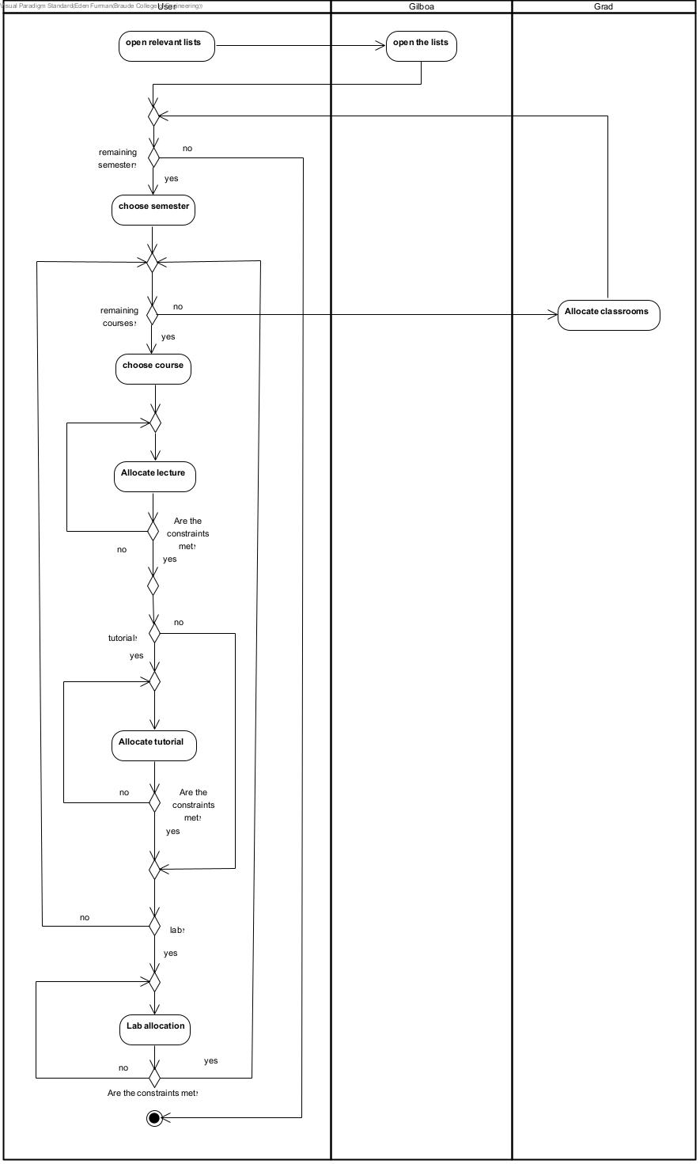
Maintaining continuous communication with the client throughout the development cycle helps ensure that the final system will not only be a technological solution, but also a practical tool that reduces manual workload and significantly improves the scheduling process in the department.
Figure 1: Ora’s timetable workflow
* Further information on the systems Gilboa and Grad (see Appendices 9.2)

3.3 Requirements Elicitation Process
The system requirements were derived primarily from the ongoing communication with the client, as described (see Section 3.2).
Based on this interaction, the requirements were defined to reflect the real scheduling workflow, including relevant hard and soft constraints and user needs. In addition, existing departmental materials such as previous timetables and Excel files were reviewed to better understand the data formats used in the current process.
Several additional requirements were included based on common practices in automated timetabling systems, such as support for Excel import and export, ranking timetable solutions according to soft-constraint violations, adjustable constraint weights, and system feedback during execution.

3.4 System Requirements

3.4.1 Functional Requirements
- The system will allow importing raw data (lecturers, courses, classrooms) from Excel files, in addition to manual input and editing.
- The system will receive all constraints and generate three possible timetables that satisfy all hard constraints and rank them based on soft-constraint violations.
- The system will support multi-level constraints (lecturer, course, classroom) with adjustable weights.
- The system will support generating a new timetable after new data is added.
- The system will show clear information in case of failure (for example, if no valid timetable can be generated).
- The system will allow saving and exporting the chosen timetable (or any of the three options) to Excel file.
- The system will provide a data management option to delete historical timetables and old data to free up storage space.
- The system will support basic role management with limited permissions.
- the system will display which hard constraints were violated, in case no valid solution is found.

3.4.2 Non-Functional Requirements
- Performance & Progress Bar: Maximum running time of 2 minutes, with a required progress bar during execution.
- The system will produce a timetable in a near-optimal way.
- Language & Responsiveness: Full support for Hebrew and English, and a responsive UI for different screen sizes.
- Availability: The Java server must be deployed in the cloud and available 24/7 for viewing the final timetable.
- Security: Firebase Security Rules must ensure that only the server can write data.
- The system will include only two roles: scheduler/admin (full permissions) and developer (debug/admin tools).
- Visual Output: The timetable will be displayed in a graphical table with different colors for lectures, tutorials, and labs.

3.5 Tools and Technologies
The timetabling problem is addressed using a custom, department-specific formulation based on the CSP paradigm. The proposed formulation defines a tailored variable structure, domain construction, constraint decomposition, cost function, and heuristic strategy, designed to reflect the academic structure, institutional rules, and practical scheduling requirements of the department. Rather than relying on a generic CSP solver or an off-the-shelf allocation algorithm, the scheduling engine integrates these components into a dedicated search process that efficiently prunes the search space and produces valid and practical timetables. The model consists of the following main components:
- Variables
- Domains
- Constraints
- Objective (cost) function
- Search strategy and heuristics
Each variable represents a single lesson that must be assigned a day, a starting time frame, and a room. A time frame represents the starting time of a lesson (e.g., frame 1 corresponds to 08:30). The possible assignments for each lesson are defined by its domain, which is constructed according to institutional rules and resource availability (see Sections 9.1.2–9.1.3).
The scheduling process is guided by hard constraints, which must be satisfied in every valid timetable, and soft constraints, which define preferences and are used to evaluate and compare different solutions through a cost function (see Sections 9.1.4-9.1.7).
The solution is generated using a CSP search process that incrementally assigns values to variables. At each step, the algorithm selects the next variable and chooses among its feasible values according to predefined heuristics and cost-based preferences, while enforcing constraint propagation during the search. These heuristics operate on two complementary levels:
- variable-selection heuristics (e.g., MRV, Variable Ordering Heuristic, Weighted Value Ordering), which determine the next lesson to be scheduled.
- value-selection heuristics (e.g., Forward Checking), which prioritize assignments that reduce future conflicts and domain shrinkage (see Sections 9.1.8–9.1.9).
A complete and formal description of the CSP model and the search process is provided in the appendices (see Appendix).

To provide a high-level overview of the scheduling logic, the main flow of the CSP-based timetabling algorithm is illustrated in the following diagram (see Figure 2). For a more detailed description of the algorithm, please see Appendix 9.
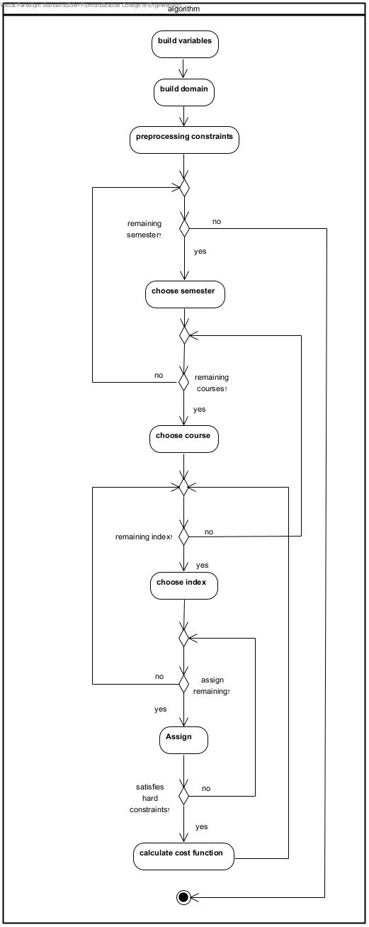

Figure 2: CSP-based timetabling algorithm

The CSP-based scheduling engine is implemented on a Java-based server, the user interface is implemented using React, and data is stored and managed using Firebase, a cloud-based database.
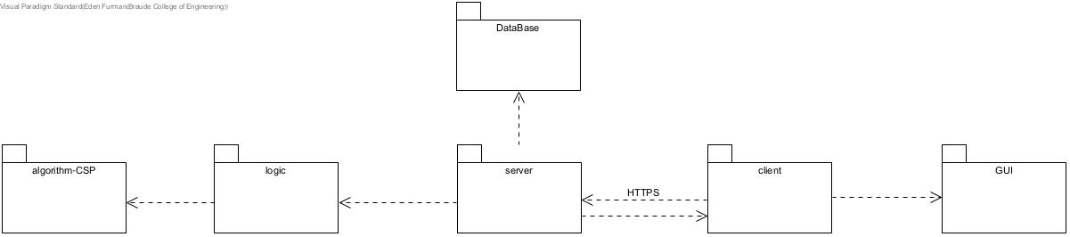
The overall structure of the system and the interaction between its main components are illustrated in the following system architecture diagram (see Figure 3).
Figure 3: System architecture diagram
The diagram shows how the different parts of the system work together. The GUI allows the user to interact with the system, while the client handles communication with the server using HTTPS.
The server processes the requests and runs the scheduling logic, including the CSP-based algorithm. The database is used to store and manage the system’s persistent data (such as courses, lecturers, rooms, and saved schedules).

The main operational flow of the system, from user interaction through the scheduling process to the generated output, is illustrated in the following diagram (see Figure 4).
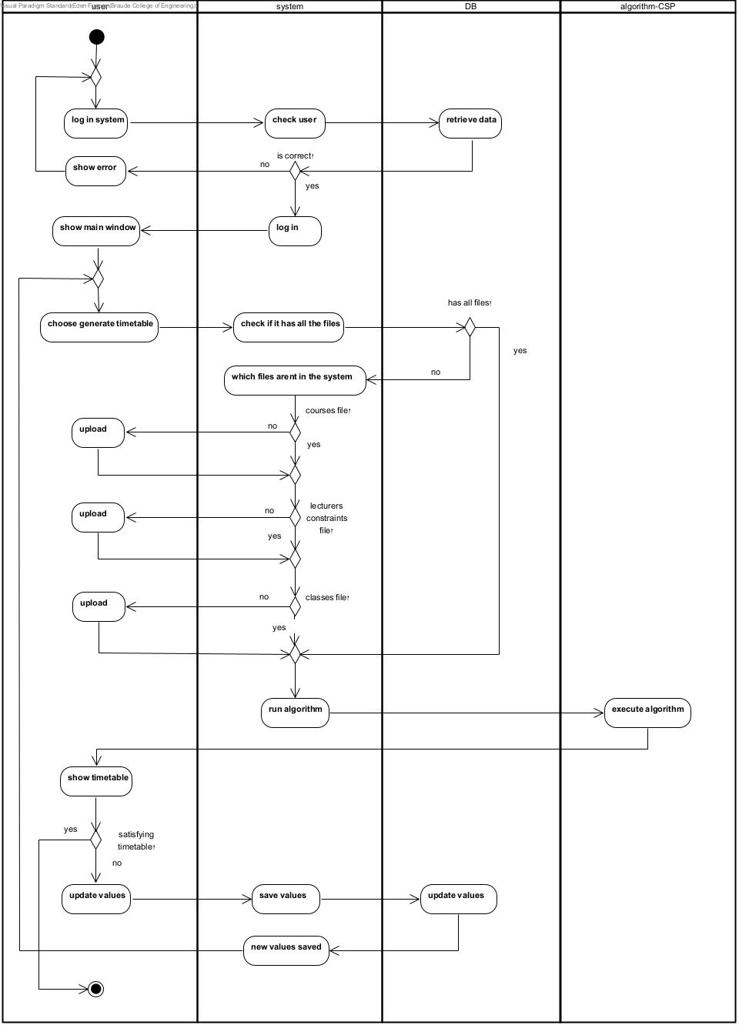

s

Figure 4: System data flow and scheduling

3.6 System Screens
The system provides a user-friendly interface composed of several main screens, each supporting a different stage of the timetable creation process:
- Dashboard: presents an overview of all loaded data in the system. It clearly indicates whether essential information is missing, making it easy for the user to identify incomplete datasets. From this screen, the user can import data, export data to Excel, and initiate the creation of new timetables (see Figure 5).
- Courses: display the list of courses loaded into the system along with their associated details. The user can view, edit, and manually add courses as needed (see Figure 6).
- Lecturers: contain a list of all available lecturers, including their personal details and teaching availability hours.
- Classrooms: presents all classrooms available for scheduling, including their type (laboratory, standard classroom, or auditorium) and seating capacity. The user can edit existing classrooms or add new ones manually (see Figure 7).
- Generate: The generate screen is responsible for configuring and running the scheduling process. It includes a list of hard constraints, some of which can be enabled or disabled, as well as a set of soft constraints with adjustable weights to control their relative importance (see Figure 8). At the bottom of the screen, a Generate Timetable button starts the scheduling process. During execution, the user receives real-time feedback through a progress indicator that visualizes the system’s advancement (see Figure 9).
- Timetable: displays the three timetable options generated by the system. The user can review each option, save selected timetables, and export them to Excel files (see Figure 10).
- History: shows a list of previously generated timetables, including their creation date and overall score.
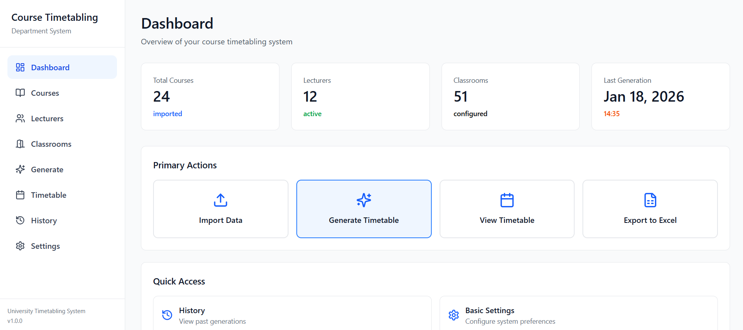
- Settings: provides general system configuration options, such as interface preferences and other basic settings.
Figure 5: dashboard
Figure 6: Course screen
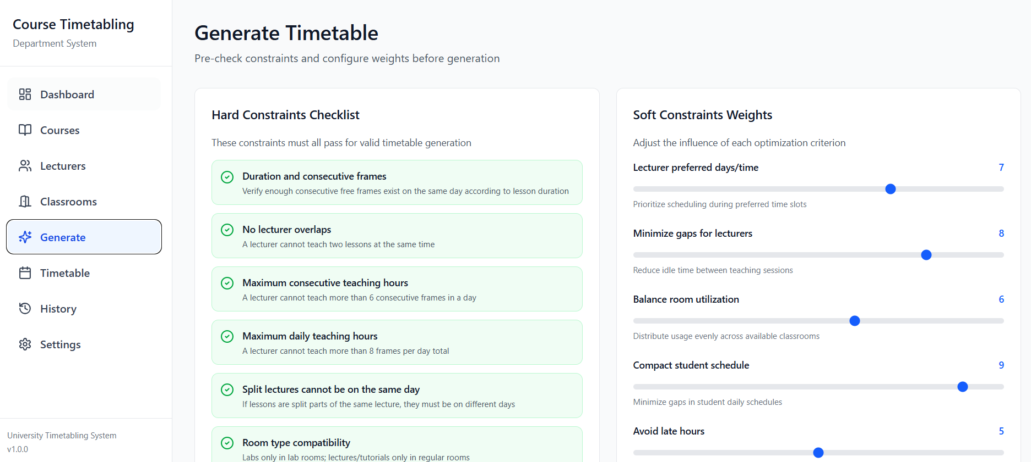
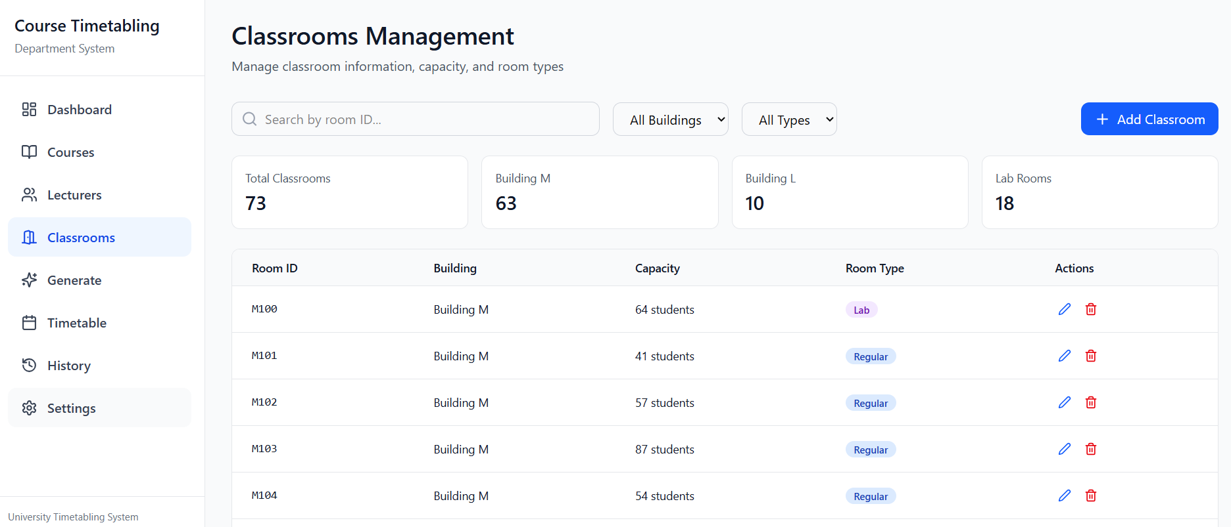
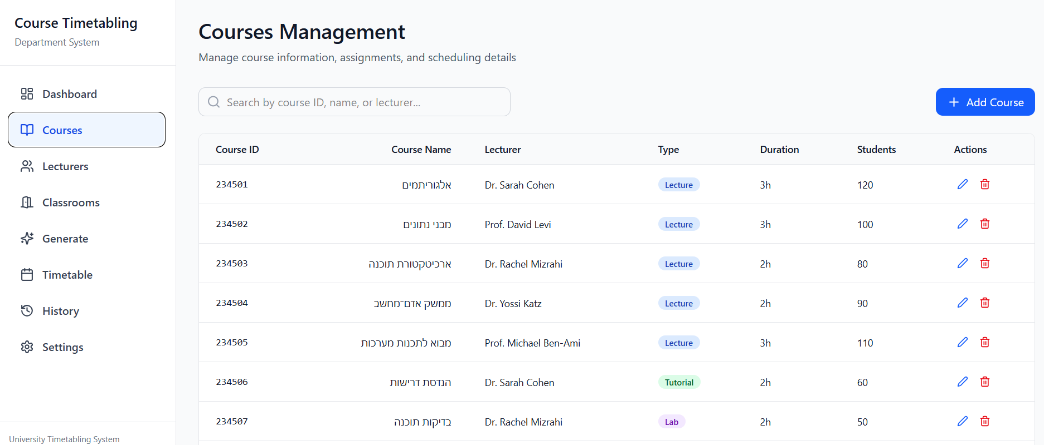
Figure 8: Generation screen
Figure 7: Classrooms screen
Figure 6: Course screen
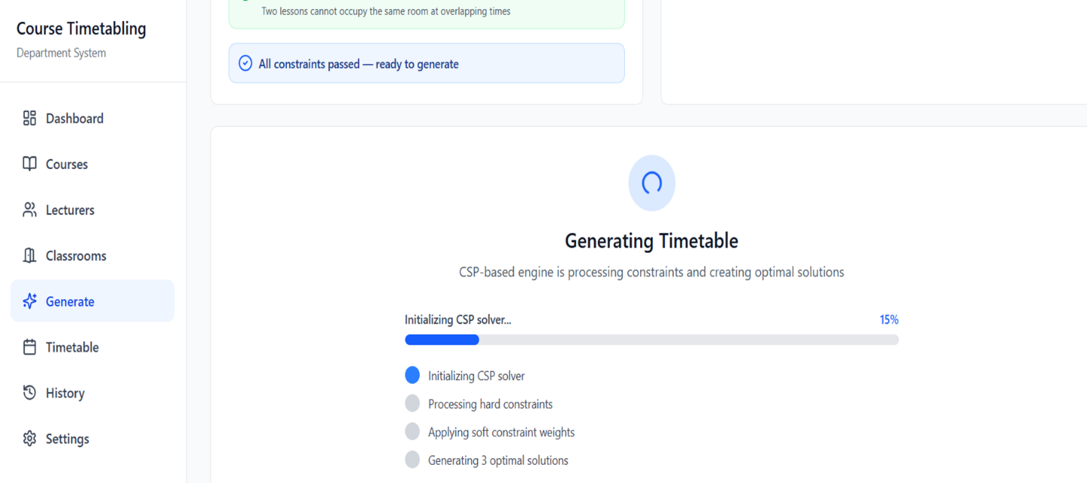
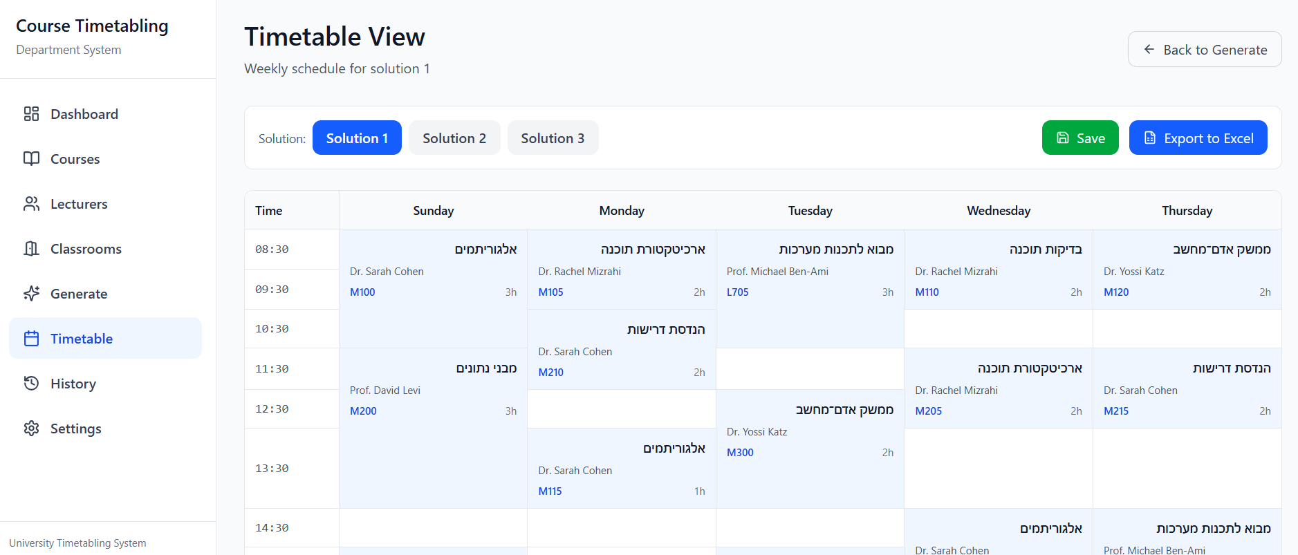
Figure 9: Generate screen – progress bar
Figure 10: Timetable screen

4. Expected Challenges
Although the timetabling algorithm was designed with careful consideration of the main constraints and a well-defined cost function, additional challenges are expected to emerge during the actual implementation and development phases. Real-world scheduling problems are characterized by numerous details and interactions that cannot always be fully anticipated or formalized at the theoretical design stage.
Throughout the development process, secondary constraints, unforeseen dependencies between system components, and specific edge scenarios may arise that were not included in the initial model. Even when such constraints appear minor, they may significantly affect the feasibility and quality of the produced timetable. Addressing these issues may require extending, refining, or modifying parts of the algorithmic model and the selected heuristics.
Another central challenge lies in the ability to produce a timetable that is not only formally valid but also practically preferable from the department’s perspective. In situations involving multiple and potentially conflicting requirements, finding a solution that balances these demands and remains useful in practice often requires iterative tuning and continuous improvement of the scheduling process. Consequently, the development process is not expected to be linear. Instead, it necessitates an iterative approach involving problem identification, solution adaptation, and repeated reassessment of the assumptions underlying the algorithm.
Finally, there is a practical limitation related to the use of the free-tier cloud database service. Since the available storage space in the free version is limited, the system cannot retain historical data indefinitely. Therefore, the user will be required to manually delete old data approximately every year in order to prevent the database from reaching its storage limit.

5. Success Metrics
The success of the project is defined by meeting the following quantitative and measurable requirements:
- Hard Constraint Adherence: 100% of the generated timetables must satisfy all defined hard constraints to ensure a valid and legal schedule.
- Soft Constraint Fulfillment: At least one of the generated solutions must satisfy at least 80% of the defined soft constraints (preferences).
- Algorithm Performance: The automated scheduling process must complete and present results within a maximum timeframe of 2 minutes.
- Solution Diversity: The system must consistently provide 3 distinct valid timetable options for each successful execution.
- Failure Diagnostics: In cases where no feasible solution exists, the system must accurately identify and report 100% of the conflicting hard constraints.
- Data Integrity: 100% success rate in manual data management (Add/Edit/Delete) and full synchronization with the cloud database.
- Integration Reliability: 100% accuracy in importing raw data from Excel and exporting the final chosen timetable back to Excel format.
- System Availability: The cloud-based Java server must maintain 24/7 availability for viewing the final schedules.
- User Satisfaction: The system must achieve a score of 80 or higher on the System Usability Scale (SUS) (see Section 6.2).

6. Evaluation Process

6.1 Testing Plan
This section outlines the testing plan used to verify the correctness and practical usability of the scheduling system.
Table 1 presents the main test cases defined for this purpose.
Test ID | Component / Feature Tested | Test Procedure (User Action) | Expected Result
TC-01 | Course data file loading | The user loads an Excel file containing course and lesson data | The data is successfully loaded and displayed in the system
TC-02 | Classrooms file loading | The user loads an Excel file containing classroom and room data | Classroom data is successfully loaded and available for scheduling
TC-03 | Lecturer availability file loading | The user loads an Excel file containing lecturer availability information | Lecturer availability data is loaded and stored for use by the algorithm
TC-04 | Input validation | The user loads one of the Excel files with missing or invalid data | The system detects the error and displays an appropriate message
TC-05 | Feasible timetable generation | The user runs the scheduling algorithm after all input files are loaded | The system generates solutions that satisfy all hard constraints
TC-06 | No-solution scenario | The user runs the algorithm when no feasible solution exists | The system does not return a timetable and displays an informative message
TC-07 | Multiple solution generation | The user runs the algorithm on valid input data | The system generates three different timetable solutions
TC-08 | Solution ranking | The user views the generated solutions | The solutions are ranked according to the soft constraints
TC-09 | Solution diversity | The user compares the generated solutions | Meaningful differences exist between the solutions
TC-10 | Runtime and progress feedback | The algorithm is executed on realistic input data | Runtime remains reasonable and progress feedback is displayed to the user
TC-11 | Exporting the timetable | User selects a generated timetable and clicks "Export" | An Excel file is created with the correct schedule data
Table 1

6.2 User Evaluation
Since the system was developed specifically for Ora, assistant head of Department, a key part of our testing strategy is to validate the system's usability and ensure it is well-suited for her needs. To quantitatively assess usability, the System Usability Scale (SUS) questionnaire will be used [10].
After completing the SUS questionnaire, the following open-ended questions will be asked to gather specific insights regarding the user experience:
- Were there specific moments during the process where you felt stuck or needed additional assistance? If so, at which stages?
- Which parts of the system or the scheduling process felt the most complex or unclear to you?
- If you could change one thing about the system to make it better for your needs, what would it be?

7. AI Tools and Prompts Used
Artificial intelligence tools, including GPT and Gemini, were used during the development of this project to support idea refinement, improve textual formulations, and assist in identifying relevant sources. In addition, the system’s screen mockups were generated using Figma’s AI-based design tools, based on predefined prompts (see Appendices 9.3). All AI tools were used in an advisory capacity only. The authors reviewed and edited all content and designs to ensure they meet the project’s requirements and take full responsibility for the final version.

8. References
- Carter, M., & Laporte, G. (1998). Recent developments in practical course timetabling. E. Burke, M. Carter, eds. Practice and Theory of Automated Timetabling. Springer Lecture Notes in Computer Science Series, 1408, 3-19.
- Chen, M. C., Goh, S. L., Sabar, N. R., & Kendall, G. (2021). A survey of university course timetabling problem: perspectives, trends and opportunities. IEEE Access, 9, 106515-106529.
- Feizi-Derakhshi, M. R., Babaei, H., & Heidarzadeh, J. (2012, September). A survey of approaches for university course timetabling problem. In Proceedings of 8th international symposium on intelligent and manufacturing systems, Sakarya University Department of Industrial Engineering, Adrasan, Antalya, Turkey (pp. 307-321).
- Gülcü, A., & Akkan, C. (2020). Robust university course timetabling problem subject to single and multiple disruptions. European Journal of Operational Research, 283(2), 630-646.
- Hirex, "The 10 Best Employee Scheduling and Shift Planning Software Tools and Apps".
- Lewis, R. (2008). A survey of metaheuristic-based techniques for university timetabling problems. OR spectrum, 30(1), 167-190.
- MirHassani, S. A., & Habibi, F. (2013). Solution approaches to the course timetabling problem. Artificial Intelligence Review, 39(2), 133-149.
- Sabar, N. R., Turky, A., Song, A., & Sattar, A. (2020). An evolutionary hyper-heuristic to optimise deep belief networks for image reconstruction. Applied Soft Computing, 97, 105510.
- Shaker, K., & Abdullah, S. (2010, December). Controlling multi algorithms using round robin for university course timetabling problem. In International Conference on Bio-Science and Bio-Technology (pp. 47-55). Berlin, Heidelberg: Springer Berlin Heidelberg.
- System Usability Scale. (n.d.). Wikipedia. Retrieved January 2026, from https://en.wikipedia.org/wiki/System_usability_scale

9. Appendices
9.1 Algorithm Description
9.1.1 CSP-Based Timetabling Algorithm
The CSP formulation presented in Section 3.5 is detailed in this appendix. The timetabling model is composed of the following elements:
- Variables
- Domains
- Constraints
- Objective (Cost) Function
- Search Strategy and Heuristics
A time frame represents the starting time of a lesson. For example, frame 1 corresponds to a lesson that starts at 08:30.
9.1.2 Variables
The variables are a list of $X_{i}$, where each $X_{i}$ is an object representing a single lesson (event) with the following fields:
- courseID
- index
- lecturerID
- groupID
- type
- duration
- splitGroupId
- semester
- credits
The fields are defined as follows:
index – the internal index of the lesson within the course. Lower values of index indicate higher scheduling priority. For example, lectures receive indices 1, 2, and then tutorials receive higher indices.
semester – an integer indicating the recommended semester in which the course is taught (1 for semester A , 2 for semester B).
groupID – an integer representing the teaching group within the same semester (group 1, group 2, etc.). For elective courses, groupID is used to indicate the relevant track/cluster.
splitGroupId – this field marks lessons that were split into multiple parts. Split lessons receive numeric values starting from 1 and up, indicating that the parts belong to the same original lesson. Non-split lessons use splitGroupId = 0. This field is used to enforce a hard constraint: different parts of a split lesson cannot be scheduled on the same day.
Each $X_{i}$ is generated from a row in the Excel file containing the list of lectures. Each row (representing a lesson) becomes one variable $X_{i}$. If a lesson has a duration greater than 3 hours, it is split into two variables.
For each variable $X_{i}$, we assign a day, a starting frame, and a room. The starting frame defines the exact time at which the lesson begins.
9.1.3 Domains
Initially, each variable shares the same base domain, representing all possible time slots in the timetable (all valid days and frames). For example, all days from frame 1 to frame 12, with exceptions such as active break on Tuesday in frames 4–5, Friday limited to frame 6 and other institutional rules. The domain of each variable $D_{i}$ is defined as: $(day,start,roomID)$. Where: day is the day of the week on which the lesson can be taught, start is the frame index of the starting time and roomID is the room namber.
The domain of each variable represents only the starting frame, while the duration of the lesson is handled in the constraints (as a requirement for consecutive frames). Therefore, not every starting frame in the domain is necessarily valid, the actual feasibility of a starting frame is checked against the lesson duration in the hard constraints.

An example of an initial domain$D_{i}$ (before any filtering):

$D_{i}$ = {

(Sun,1,_), (Sun,2,_), (Sun,3,_), (Sun,4,_), (Sun,5,_), (Sun,6,_), (Sun,7,_), (Sun,8,_), (Sun,9,_), (Sun,10,_), (Sun,11,_), (Sun,12,_)

(Mon,1,_), (Mon,2,_), (Mon,3,_), (Mon,4,_), (Mon,5,_), (Mon,6,_), (Mon,7,_), (Mon,8,_), (Mon,9,_), (Mon,10,_), (Mon,11,_), (Mon,12,_)

(Tue,1,_), (Tue,2,_), (Tue,3,_), (Tue,4,_), (Tue,7,_), (Tue,8,_), (Tue,9,_), (Tue,10,_), (Tue,11,_), (Tue,12,_)

(Wed,1,_), (Wed,2,_), (Wed,3,_), (Wed,4,_), (Wed,5,_), (Wed,6,_), (Wed,7,_), (Wed,8,_), (Wed,9,_), (Wed,10,_), (Wed,11,_), (Wed,12,_)

(Thu,1,_), (Thu,2,_), (Thu,3,_), (Thu,4,_), (Thu,5,_), (Thu,6,_), (Thu,7,_), (Thu,8,_), (Thu,9,_), (Thu,10,_), (Thu,11,_), (Thu,12,_)

(Fri,1,_), (Fri,2,_), (Fri,3,_), (Fri,4,_), (Fri,5,_), (Fri,6,_)
Here, “_” denotes any roomID that is compatible with the lesson type of $X_{i}$.

}
To optimize the search, the roomID values are pre-filtered for each variable based on room type compatibility and capacity requirements before the algorithm starts . This ensures that the domain only contains rooms that can accommodate the specific lesson.
9.1.4 Constraints
We divide the constraints into two main categories:
- Preprocessing constraints – applied once, before the search starts.
- Dynamic constraints – checked and enforced during the search.
Preprocessing Constraints
These constraints are used to reduce domains before running the CSP search.
Global institutional constraints – constraints coming from the college, such as:
- During English lessons, no other lessons may be scheduled.
- Active breaks.
- Non-teaching frames.
These time slots are removed from the domains of all variables.
Lecturer availability constraints – We reduce the domain of each variable according to the individual constraints of its lecturer. If a lecturer cannot teach on a certain day and during specific hours, these slots are removed from the domains of all variables taught by that lecturer.
All these constraints are static, they do not depend on the partial assignment during search and therefore are applied only once before the algorithm starts.
9.1.5 Dynamic Hard Constraints
The next phase is handling constraints during the search, i.e., while assigning values to variables.
The hard constraints enforced during runtime are:
- Duration and consecutive frames:
For every proposed assignment of a lesson to a starting frame, we verify that there are enough consecutive free frames on the same day according to the lesson’s duration. If not enough consecutive frames are available, the value is considered invalid for the variable.

- No lecturer overlaps:
A lecturer cannot teach two lessons at the same time. When we assign a variable $X_{i}$​ representing a lesson taught by lecturer 𝐿, we mark that time window as “occupied” for all other variables corresponding to lessons of the same lecturer. Their domains are updated accordingly.

- Maximum consecutive teaching hours:
A lecturer cannot teach more than 6 consecutive frames.
Before each assignment, we check whether adding this lesson would cause the lecturer to exceed 6 consecutive occupied frames on that day.

- Maximum daily teaching hours:
A lecturer cannot teach more than a total of 8 frames per day.
After each assignment, we check whether the total number of occupied frames for this lecturer on that day exceeds 8.

- Split lectures cannot be on the same day:
For courses where a long lecture (e.g., 4 hours) is split into two separate variables (two 2-hour lessons), we require that these parts not be scheduled on the same day.
Formally, if $X_{i}$ and $X_{j}$ are two variables representing parts of the same split lecture of the same course, then we must have: $day\left(X_{i}\right)≠day\left(X_{j}\right)$
During the search, when the algorithm tries to assign the second part, it checks whether the first part has already been scheduled. If it has, and the proposed day for the second part equals the day of the first part, the assignment is considered invalid, and the corresponding value is removed from the domain of the second variable.

- Room type compatibility:
Lab lessons must be assigned only to laboratory rooms. Lectures and tutorials must be assigned only to regular classrooms.

- Room capacity constraint
Each room has a defined capacity. A lesson $X_{i}$ may be assigned to roomID only if:
$${size(X}_{i})≤ capacity(roomID)$$
- No Room Overlaps:
Two lessons cannot occupy the same room at overlapping times. For lessons $X_{i}$ and $X_{j}$ assigned to the same room and day:
Their time intervals $[start , start + duration - 1]$must not overlap.
Only after all hard constraints are satisfied do we evaluate soft constraints.
9.1.6 Soft Constraints
Soft constraints provide a cost that is used to evaluate and compare different valid timetables.
The best timetable is the one with the lowest total cost.
Each soft constraint can be assigned a weight to control its importance.
- Minimizing gaps (holes) in the lecturer’s timetable:
To reduce unnecessary breaks, we prefer scheduling lessons close to frames where the lecturer already teaches. For each day, we locate the lecturer’s occupied frames and assign lower cost to nearby frames, making them more likely to be selected. This encourages the algorithm to place lessons next to each other and minimize gaps in the daily schedule.

- Prefer scheduling difficult courses in the morning:
Some courses are considered more demanding, and we prefer to place them in the morning when students are more focused. A predefined list marks these “difficult courses.” For lessons in this list, the algorithm gives lower cost to morning time slots and higher cost to later ones, encouraging morning scheduling unless no valid option is available.

- Maintaining continuity of teaching days for the lecturer:
To avoid spreading a lecturer’s lessons across many days, we prefer scheduling new lessons on days the lecturer already teaches. Days with existing lessons receive lower cost, so the algorithm tries to place additional lessons there before opening new teaching days. This creates a more compact and convenient schedule.

- Avoid overlapping lecture, tutorial, and lab components of the same course:
To prevent components of the same course from being scheduled at the same time, we apply a penalty to overlapping time slots. After scheduling one component (e.g., the lecture), we add a penalty to the same time slot in the domains of the other components (tutorials, labs). This encourages the algorithm to place each component in different time frames and avoid overlaps.

- Room Size Efficiency
Each lesson $X_{i}$ has a defined class size ${size(X}_{i})$, and each room $r$ has a capacity $capacity(r)$.
Assigning a lesson to a room with much more capacity than needed is considered inefficient. Therefore, we associate a cost with each assignment based on:
$cost=\left|capacity\left(roomID\right)- {size(X}_{i}\right)|$ . Larger differences result in higher cost, meaning the algorithm prefers assignments where the room capacity is closer to the actual class size.

9.1.7 Cost Function
For each variable $X_{i}$ (a lesson) and each possible value 𝑣 in its domain (a specific time slot), we compute a local cost describing how undesirable this assignment is with respect to the soft constraints. In this way, the algorithm does not merely look for any valid solution but also compares between different valid timetables and prefers one that minimizes violations of preferences (soft constraints) of lecturers and the institution. The cost is based on the defined soft constraints.
For each soft constraint $C_{k}$, we assign a weight $w_{k}$. For each value 𝑣, we compute a penalty term ${penalty}_{k}\left(v\right)$, which measures how much the assignment of $X_{i}=v$​ deviates from the preferred condition (e.g., creating a gap, scheduling a difficult course in a late hour, opening a new teaching day for the lecturer, etc.).
The local cost of value $X_{i}$ is defined as:
$${cost}_{i}\left(v\right)= \sum_{k}{w_{k}*{penalty}_{k}\left(v\right)}$$
During the search, after filtering out all values that violate hard constraints, the algorithm selects for each variable the value with the minimum cost. For a complete assignment 𝑆 of all variables, the total cost is:
$$cost\left(s\right)= \sum_{i}{{cost}_{i}(S\left(x_{i}\right))}$$
The goal of the algorithm is to find a valid timetable (satisfying all hard constraints) for which the total cost $cost\left(s\right)$ is minimal.
In practice, this can be viewed as follows, each time slot in the domain of each lesson has a “priority score,” and the algorithm always prefers to assign the lesson to the time slot with the lowest score, as long as all hard constraints are satisfied.

9.1.8 Variable Ordering Heuristic
To ensure efficient search in the space of solutions and to reduce the number of backtracking steps, we define a total ordering over the set of variables $\left\{x_{1}, x_{2},…,x_{n}\right\}$ This ordering determines the sequence in which variables are processed during the algorithm. The ordering is defined as a hierarchy of criteria:
- Primary order – by semester
Each variable $x_{i}$has a value $semester(X_{i})$, We define:
$X_{i}> X_{j}$ if $semester\left(X_{i}\right)> semester\left(X_{j}\right)$
In other words, variables belonging to a lower semester are given higher priority (they are assigned earlier) than variables of higher semesters.
- Secondary order within a semester – by groupID
For variables belonging to the same semester, we define an additional ordering:
$$if semester\left(X_{i}\right)=semester\left(X_{j}\right) and groupID\left(X_{i}\right)>groupID\left(X_{j}\right)$$
$$⇒ X_{i}>X_{j}$$
Thus, within a given semester, courses with a lower groupID are assigned earlier.
- Course priority within a semester – by credits
Within the same semester, courses are also prioritized according to their number of credit points. Let $credits\left(X_{i}\right)$ denote the number of credits of the course associated with variable $X_{i}$. For two variables $X_{i}$and $X_{j}$ that belong to the same semester, we define: $X_{i}$ is prioritized before $X_{j}$ if $credits\left(X_{i}\right)>credits\left(X_{j}\right)$ .
This means that, within each semester, courses with a higher academic weight are scheduled earlier.

- Course ordering – full assignment of a course before moving to the next course
Each variable has an associated course, we define:
$$if semester\left(X_{i}\right)=semester\left(X_{j}\right),$$
$$groupID\left(X_{i}\right)=groupID\left(X_{j}\right),$$
$$couseID\left(X_{i}\right)>courseID(X_{j})$$
$$⇒ X_{i}>X_{j}$$
In addition, for each courseID there is a set of variables $\left\{x_{1}, x_{2},…,x_{n}\right\}$ representing lectures, tutorials, and labs of the same course. We require that all variables of a given course be assigned before moving on to the next course.
- Internal order within a course – by type and index
We define a fixed order between lesson types: $lecture→tutorial→lab$
A lower index value represents higher priority for scheduling.
The overall order of variables is determined by the following key tuple in lexicographic order: $semester→groupID→credits→courseID→index$

9.1.9 Search Strategy: Backtracking + Forward Checking + MRV + Weighted Value Ordering
The timetable is constructed using a CSP search strategy that combines four complementary techniques:
- Backtracking
- Forward Checking
- MRV (Minimum Remaining Values)
- Weighted Value Ordering based on the soft-constraint cost function.
Backtracking
Backtracking serves as the core search mechanism. The algorithm assigns values to variables one at a time. If a chosen value eventually leads to a dead-end (i.e., no feasible assignment exists for a future variable), the algorithm backtracks, undoing previous assignments and trying alternative values. This ensures completeness: if a valid timetable exists, backtracking can find it.
Forward Checking
After assigning a value to a variable, forward checking updates the domains of all remaining unassigned variables by removing any values that can no longer lead to a valid solution. If any domain becomes empty, the assignment is immediately rejected and the algorithm backtracks.
MRV – Minimum Remaining Values
When selecting the next variable to assign, the algorithm prefers variables that have the smallest number of remaining feasible values in their domain. This heuristic identifies the “most constrained” variables first. If a variable already has very few legal options, it is better to assign it early. Otherwise, the algorithm may reach a dead-end later and need to backtrack extensively. MRV significantly improves efficiency, especially because lecturer availability and duration constraints often shrink domains very quickly.
Weighted Value Ordering (Cost-Based Value Choice)
After filtering out values that violate hard constraints, all remaining candidate (day, frame, room) values for a variable are ordered according to the cost function defined (see Section 7.1.7). For each variable $X_{i}$, the algorithm evaluates every feasible time slot 𝑣 using the previously defined cost measure ${cost}_{i}\left(v\right)$, and selects values in ascending order of cost. This ensures that the search always prefers the most desirable assignments according to the soft constraints.
While section 7.1.8 defines the initial priority ordering, the MRV heuristic dynamically selects the most constrained variable within that priority to prevent early dead-ends . The integration of MRV with Forward Checking is what allows the system to consistently meet the 2-minute performance requirement despite the problem's NP-hard complexity.

9.2 Gilboa and Grad systems
The Gilboa system contains all lecturers’ constraints. Before the beginning of each academic year, lecturers enter into the information system the days and hours during which they are available to teach. All this information appears in the Gilboa system, which also includes a list of the courses offered in the upcoming two semesters.
The Grad system is a tool for classroom scheduling. After Ora manually assigns a lecturer and a time slot, the Grad system is used to assign a classroom according to the course requirements. For example, a laboratory class requires a lab room, while a lecture with many students requires a large classroom.

9.3 AI Prompts
"Design a clean and user-friendly web interface for a university course timetabling system. The system is intended for a department secretary and should be simple, clear, and intuitive. All interface text is in English, while course names appear in Hebrew. The screens should include data tables, editing options, validation indicators, and action buttons relevant to timetable management. Focus on presenting the content of each screen only, without showing the surrounding computer or device frame."

